1. Hamster 2

I included my Group Top-Down game because it’s my most proud project. I really enjoyed the group that helped me make this project. I really love the Hamster enemy that made for the game, I loved the various level designs and themes this game explores. I love the gameplay systems of moving fast and dodging the bullets coming from the hamster.

1. Meme Rampage

I included my Group Mobile game it’s my second most proud project. My group and I really put a lot of passion into the theme and art style of this project and felt like we really communicated well together. I had fun coming up the style of the characters. It was fun making the story of this game and seeing how others reacted when playing.

1. Blender Lamps

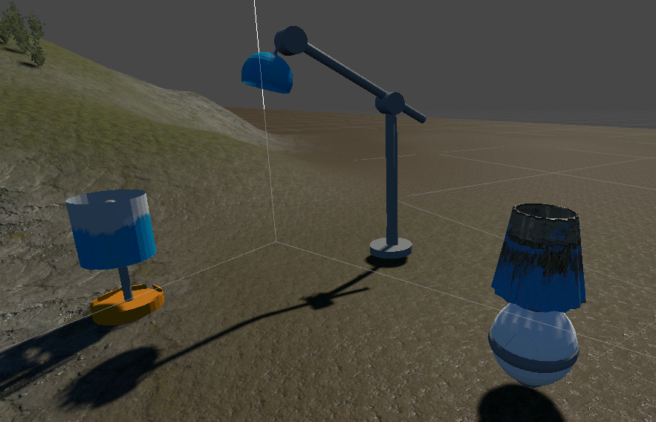

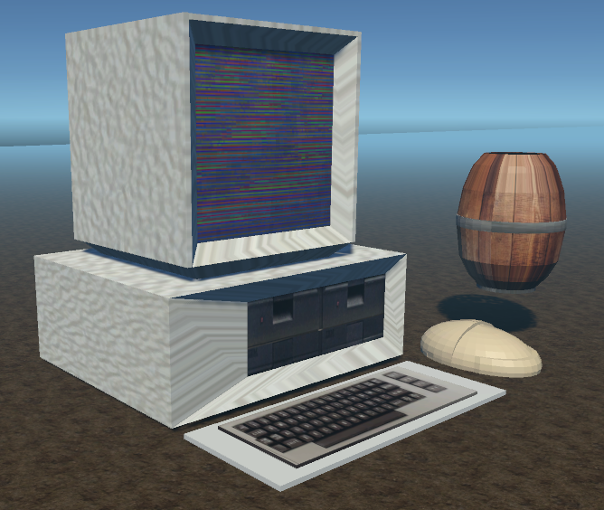I decided to put my first ever objects I made in Blender as I am proud of how they came out with all their detail. I lots of fun creating these models as through the process I learned different skills on how to make objects such as the quick key binds and tools to make the object making process faster and easier. I learned how to create real life object in Blender and learned how to import them into Unity.

1. Blender Computer

This was the first object I detailed and textured on my own. I am very proud of this creation as I really got used to the vertex grouping of texturing. I’m proud of how I was able to resemble the old look of a computer from the 80’s.

1. Unity Level  
   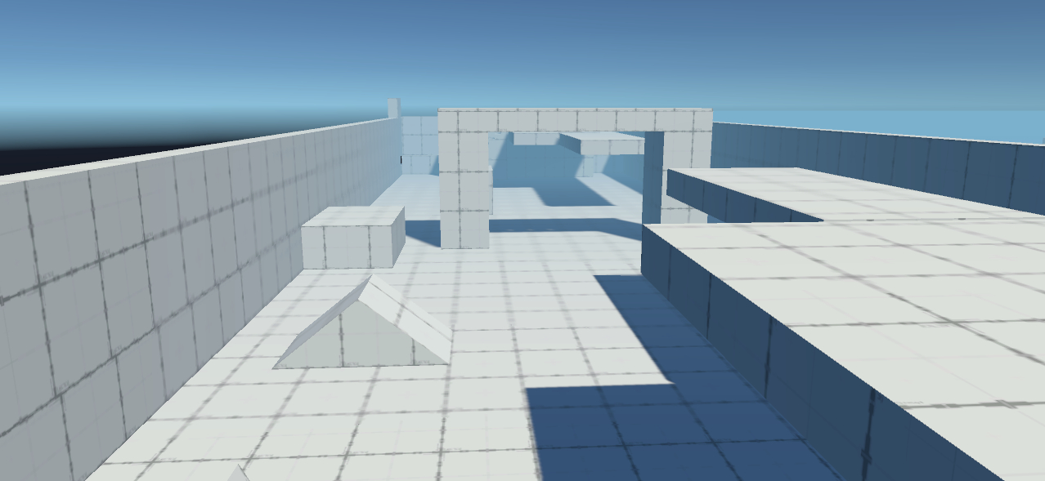

I included my first Unity level I made with the Unity Pro Builder tool. I am proud of the creation as I really loved learning the different settings of the Pro Builder tool. I had a great time making my level and loved getting used to putting different shapes together to build environment.

1. 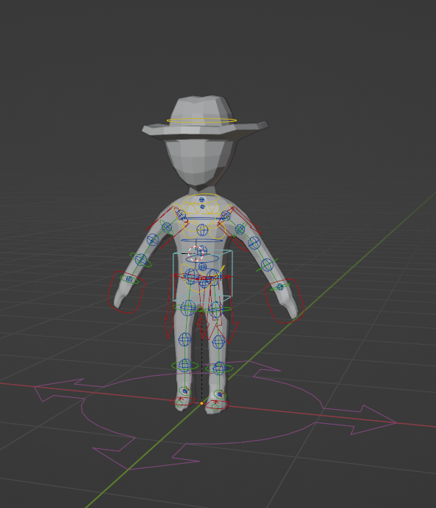Blender Character

I really loved to model as it was the first character model I’ve ever made. I learned a lot making this model like, how to keep things even all around the model and learned how to model a basic human. I learned how to rig the model and make its limbs move. I feel like I did a really great job at modeling this character and can definitely see that my Blender skills have improved.